Smart Waiver - Step-By-Step Guide
See link below to access smart waivers
https://pps.noesis-cloud.co.uk/Modules/Forms/MyForms
(Please note: you must be a registered helpdesk user to access the form)
If you experience issues with the dropdowns not working, please contact our NOESIS Helpdesk (Helpdesk: 020 3322 1935 or Home)
Section 1 – User Details

1. Directorate*
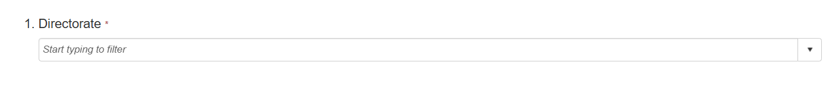
- Start typing your directorate name
- Select the correct option from the dropdown

2. Department*

- Type your department name

Section 2 – Details of Request

1. Supplying Company Name

- Start typing the supplier name
- Select the correct supplier from the dropdown list

2. If supplier not in list
- If you cannot find the supplier, enter the full company name in the box provided

3. Does the supplier handle personal data*
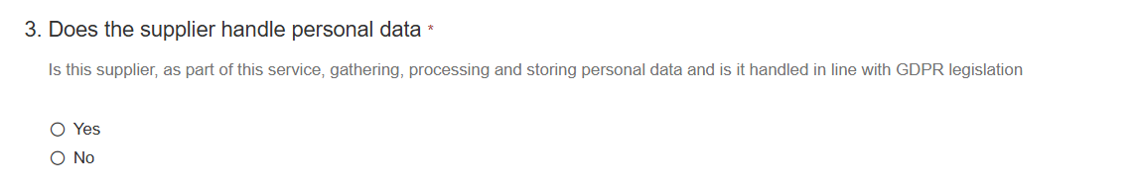
- Select Yes if the supplier will collect, store, or process personal data
- Select No if they will not

4. Goods / Services to be procured*

- Provide a clear, brief description of what is being purchased

5. Does this relate to a contract?*

- Select Yes if this purchase involves a contract or agreement
- Select No if it is a one-off purchase

6. If yes, select contract length
- Only complete this if you selected Yes above
- Click into the box, start typing, and select the correct duration

7. Funding Source*

- Select Revenue or Capital
- Revenue = day-to-day spend (e.g. services, consumables)
- Capital = large purchases/assets (e.g. equipment, projects)

8. Lead Budget Code*

- Start typing your budget code
- Select the correct option from the list

9. Capital Job/Account Code
- Only complete this if you selected Capital above
- Enter the relevant capital code

10: Total financial value being committed (Excluding VAT)

- The total upfront cost of the project or purchase, before tax (VAT).
- Take the full quoted/project cost.
- Remove VAT (if your quote includes it).

11: Will further expenditure be needed during the project lifetime?

- Will you need to keep spending money after the initial purchase?
- Select Yes → if any ongoing cost exists
- Select No → if it’s truly a one-time cost
Include:
- Maintenance contracts
- Subscriptions/licenses
- Consumables (e.g., materials, supplies)
- Repairs or servicing

12: If yes, state annual value (Excluding VAT)

Only fill this if you selected YES above.
- The total yearly cost of ongoing expenses (excluding VAT).
- Enter the final yearly amount
Include:
- Annual maintenance
- Renewals
- Regular supplies

13: Existing requisition number
- If this request relates to a previously submitted or approved request, provide its reference number.

14. Applying for a waiver reason
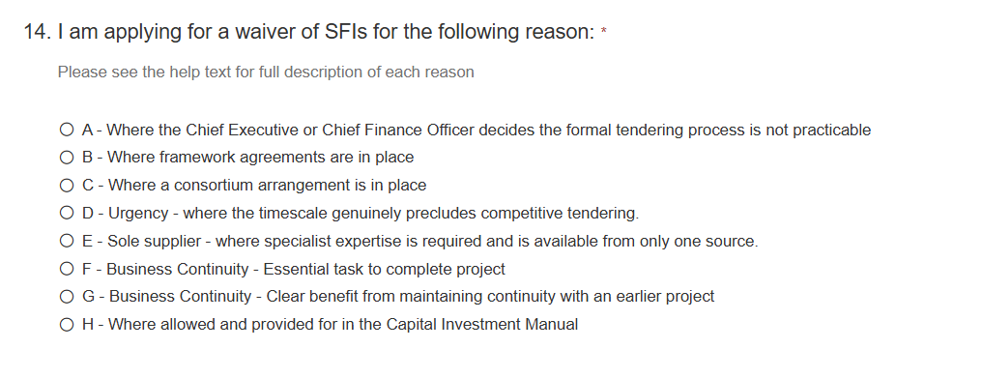

A – Formal tendering not practicable
Use when a full tender process genuinely cannot be done and CEO/CFO agrees.
- Highly specialist one-off work
- Very complex situation
- Tender would not give value

B – Framework agreement exists
Use when an approved procurement framework already in exist
- Eg: - London Procurement Partnership [LPP],Crown Commercial Service [CCS] etc
- Existing approved supplier list
- Internal framework contract

C – Consortium arrangement
Use when buying jointly with other organisations.
- Shared procurement with councils
- NHS / universities / local authority joint buy

D – Urgency / Timescale prevents tendering
Use when waiting for tender would create real risk.( Must be genuine urgency, not poor planning)
- Regulatory deadline
- Operational failure risk
- Funding deadline
- Immediate project mobilisation needed

E – Sole supplier
Use when only one supplier can do it.
- Owns existing software/IP
- Unique specialist expertise
- Only compatible provider
- Exclusive rights/licence

F – Business Continuity (Essential task to complete project)
Use when supplier must continue so project can finish.
- Mid-project and changing supplier would stop delivery
- Critical handover phase
- Existing supplier needed to complete build

G – Business Continuity (Benefit from continuity with earlier project)
Use when same supplier brings clear efficiency/knowledge benefits.
- Existing system knowledge
- Reduced mobilisation time
- Avoid duplicated cost
- Seamless extension from prior phase

H – Allowed under Capital Investment Manual
Use only if specifically allowed in policy/manual.

NB: Choosing an incorrect reason/justification for the waiver will result in the waiver being rejected, and the requirement being subjected to an appropriate procurement exercise.

15. Provide full waiver reason

You must provide further information relating to your specific requirement to support the reason chosen above.
Use this structure:
1. Background - What project/service is this for?
2. Why waiver needed - Why normal tendering unsuitable?
3. Risk if not approved - Delay, cost, service failure, deadline miss?
4. Why chosen supplier/reason is best value - Experience, continuity, compatibility, urgency etc.
5. Future plan - Will full procurement happen later?

16. Likelihood to require an SFI waiver notified in the business case

Select Yes
- The original business case said:
- likely direct award
- waiver may be needed
- incumbent supplier continuation
- urgent delivery route
- framework/direct appointment planned
Select No if
- This waiver need arose later and wasn’t in original business case.

  - If no, please provide reasons in the text box why this has now become an issue


Section 3 – Declaration

1. Please attach any backing information such as quotes

Upload evidence proving your request is reasonable and value for money. Ie Supplier quote/s.

2&3. Does the applicant have any conflicts of interest with the proposed supplier?
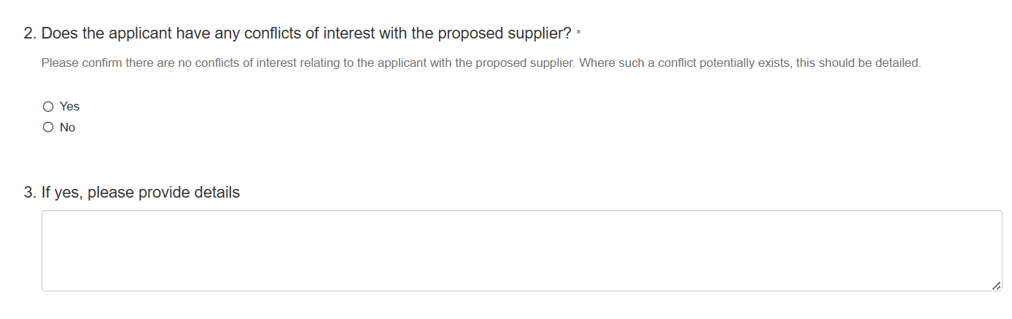
Does the person submitting this form have any personal connection to supplier?
For example (Family member works there, Friend owns company, Gifts/hospitality received, Shares/investment, Previous employment, Side business relationship)

Select Yes if any of the above apply and explain fully in Question 3
Select No if there is no conflict.

4&5. Does the budget holder have any conflicts of interest with the proposed supplier?
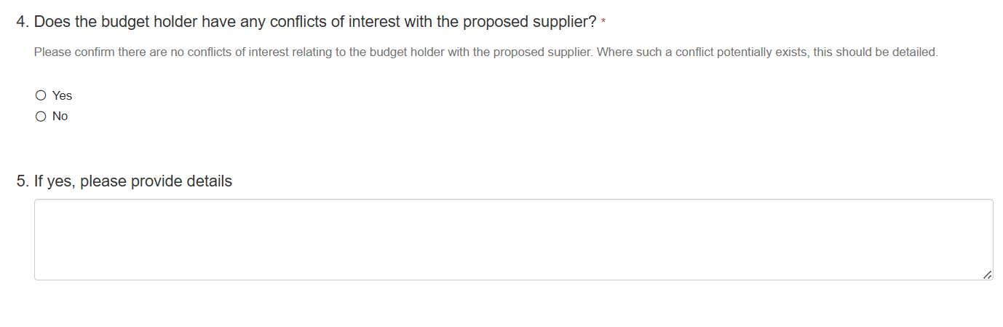
Does the budget holder have any conflicts of interest with the proposed supplier?
Same principle as Q2, but now referring to the person controlling the budget or approving spend.
Select Yes if any of the above apply and explain fully in Question 3
Select No if there is no conflict.

Section 4 - Form Submission
To submit, please click the toolbox on the right hand side and click “submit”

