Approval Delegation within PECOS
- Go to www.nhspps.uk and click “About” and “ Scheme of Delegation”
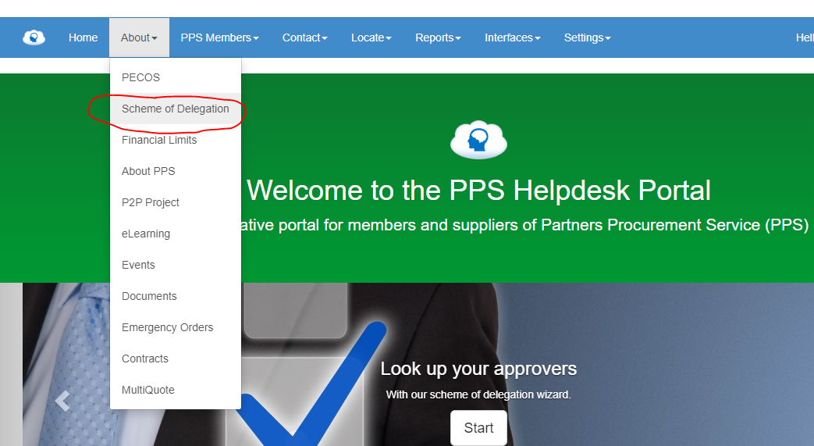
- Type in your cost centre and then review the approval level which you fall into

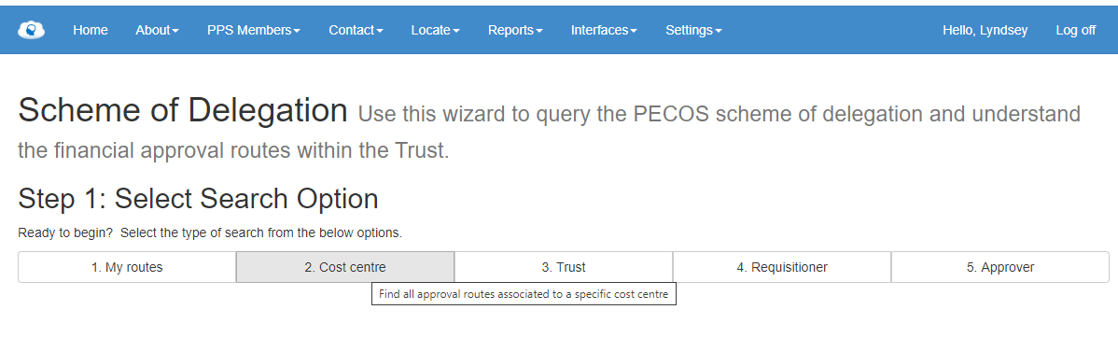
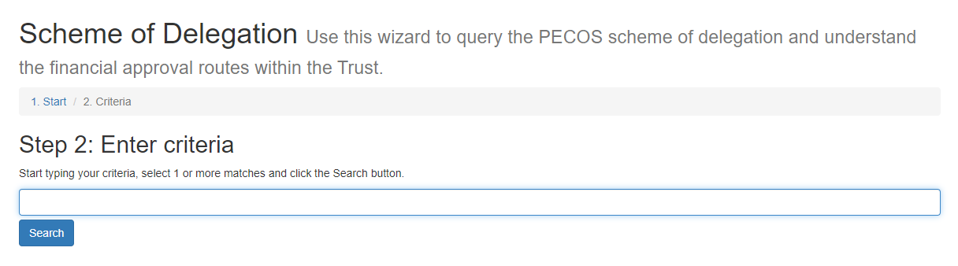

- Find name of another person in your level of approval or the one in the level above.

- Log onto PECOS: https://pps.pecosipm.com/pm/gb/pecospm.asp

- Click on “To Do” and then “Approval Delegation”
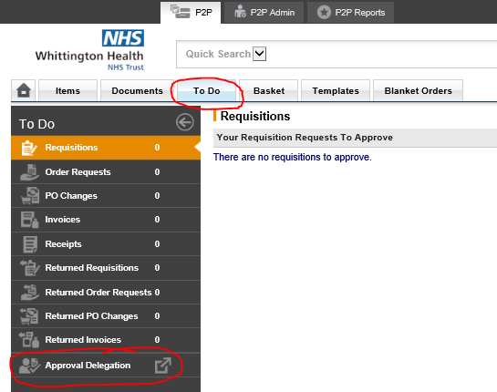

- Add your Start Date and End Date and then click “User Lookup” type the name of the person found in the Scheme of Delegation. Click “Save”.
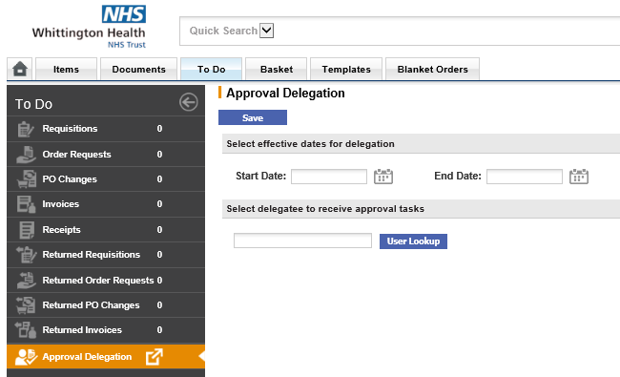
- If you do not see the approval delegation in your to do list, then please contact PPS helpdesk to switch this function on.

