# Introduction

This quick guide provides a two - page reference to users of the PECOS system of how to Expedite requisitions in to Purchase Orders (PO) ONLY for **UOR (Urgent Operational Requirements).**

# For Catalogue Items

1. In case approver(s) are not available contact PPS using the following link: <https://pps.noesis-cloud.co.uk/Modules/Enquiries/ContactUs> (an example screen shot is shown below) and call [0203 322 1935](tel:0203%20322%201935) with your enquiry reference and Requisition details to request alteration of the approver to an authorised approver for the associated cost centre that can approve within your time frame.

You should use the Scheme of Delegation wizard on the PPS Helpdesk to identify a valid alternate approver: <https://pps.noesis-cloud.co.uk/Modules/pecos/sod>

# For Non-Catalogue Items

1.      Raise and submit requisition as normal and contact PPS to inform them of the urgency of the requisition, you should also add a note in the Internal notes to state this is an urgent request and inform ALL approvers in the scheme of delegation to approve the Requisition.

2.       In case approver(s) are not available contact PPS using the following link: <https://pps.noesis-cloud.co.uk/Modules/Enquiries/ContactUs> (an example screen shot is shown below) and call [0203 322 1935](tel:0203%20322%201935) with Requisition details and request alteration of the approver to one that can approve within your time frame.

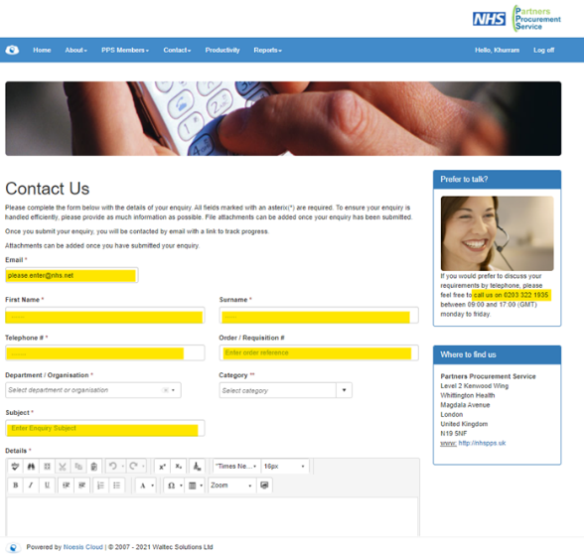

3.       Contact the above approver to approve Requisition

4.       Once Requisition is converted to a PO, inform the PPS Help Desk to follow-up.

5.       Once approved confirm with supplier the delivery of goods, services or works.

# Getting Help

If you are still experiencing problems, you can log a call with the PPS help desk either online at <http://nhspps.uk> or by calling 020 3322 1935.