**STANDING FINANCIAL INSTRUCTIONS (SFI): SUMMARY**

**Context**

The Standing Financial Instructions (SFIs) are rules to ensure our financial governance is robust. They form detailed guidance for all Trust staff about what financial decisions or commitments can be made at which levels of materiality. They apply to all staff members, regardless of role.

If, for any reason the SFIs are not complied with, full details of the non-compliance and any justification for non-compliance and the circumstances around the non-compliance shall be reported to the Audit Committee for referring action or ratification.

All members of the Board and staff have a duty to disclose any non-compliance with these SFIs to the Group Chief Financial Officer, as soon as possible.

Full SFIs are available on the Royal Free intranet, [here](https://freenet2.royalfree.nhs.uk/policy/151675/Standing-Financial-Instructions).

**Duties and responsibilities**

All Trust must provide value for taxpayers money and safeguard its assets from loss or damage. Anyone involved with creating cost, income contracting or using the property of the Trust is responsible for ensuring that they use the resources wisely, and following related policies and procedures.

The Group Chief Executive Officer is ultimately accountable to the Board of Directors, and as accounting officer, to the Secretary of State, for ensuring that the Board meets its obligation to perform its functions within the available financial resources. The Group Chief Executive has overall executive responsibility for the Group’s activities. The Group Chief Executive is responsible to the Chair and members of the Board for ensuring that its financial obligations and targets are met and has overall responsibility for the Groups system of internal control.

The Group Chief Financial Officer is responsible for ensuring that the SFIs are relevant, and policies and processes are in place to provide instruction and control to spend our resources well, and to report on what we have done with our money.

The Council of Governors are responsible for holding the Non–Executive Directors individually and collectively to account for the performance of the Board of Directors, and representing the interest of the members of the Trust as a whole and the interests of the public.

**Budget holder approval thresholds**

Below, is a summary of key approval thresholds including the governance forums that approvals should flow though.

**Detailed Scheme of Delegation**

The following is a summary guide to key financial approvals. This document should be read alongside the full SFIs. All staff, whether directly or indirectly employed or engaged by the Trust including volunteers, are within scope of the SFIs.

**Table one: Delegated budget hold authority levels**

|  |  |
| --- | --- |
| **Designated budget holder level** | **Delegate Authority** |
| 2 | Budget holder: ward manager, senior sister, operations manager, matron |
| 3 | Heads of department, general managers, clinical directors |
| 4 | Divisional directors (operations, nursing, division medical director) and corporate directors |
| 5 | Hospital directors (operations, nursing, medical, finance, chief executive), group executive management meeting |
| 6 | Assistant Director of Group Finance, Director of Finance, Commercial Finance Director |
| 7 | Group Chief Executive, Group CFO |

**Table two: Budget holder approval levels**

The below sets outs approval limits for each budget holder level, with reference to budgeted spend

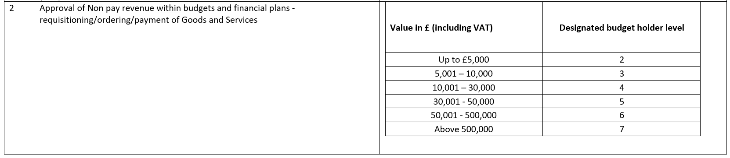

**Table three: Committee approval thresholds (revenue)**

The below thresholds apply to both non pay and pay investments outside budgets and financial plans. Forum approvals run consecutively, with comments arising from each forum reflected in the business case document presented to the next.

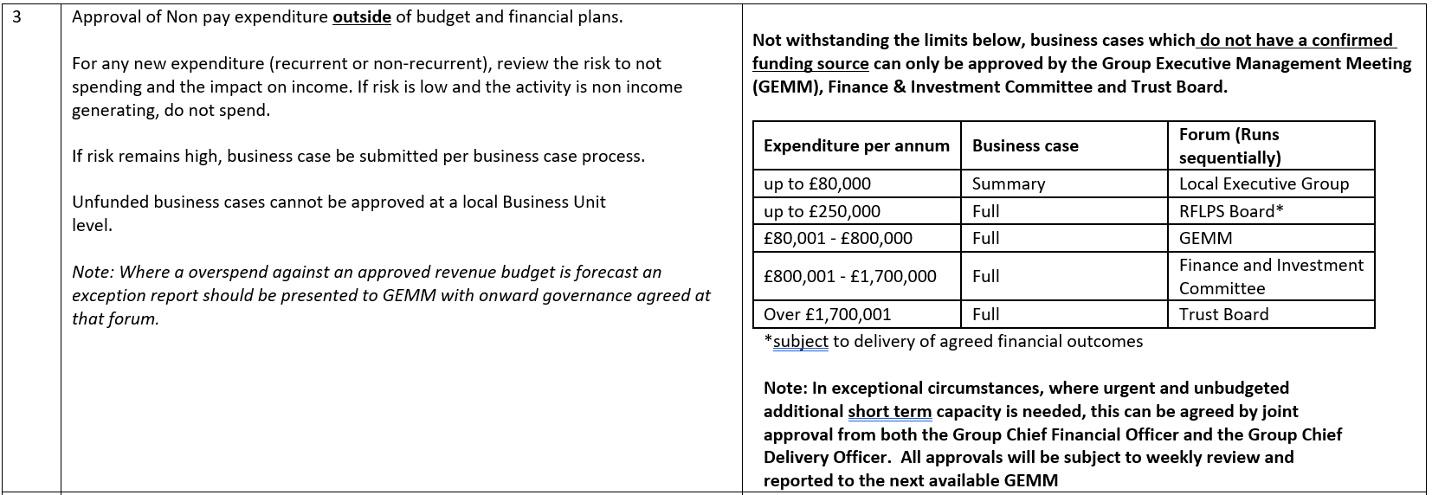

**Table four: Committee approval thresholds (capital)**

The below thresholds indicate the governance process for all capital (operational and right of use/lease) approvals. The expectation is that cases presented for consideration have a pre-agreed source of capital funding. Whilst emerging capital needs may arise during the year, as far as possible, capital investments should be identified as part of the annual capital planning cycle. This allows capital investments to be indicatively included within the annual capital plan. Funds can then be accessed subject to business case approval. Note the below limits also apply to leases.

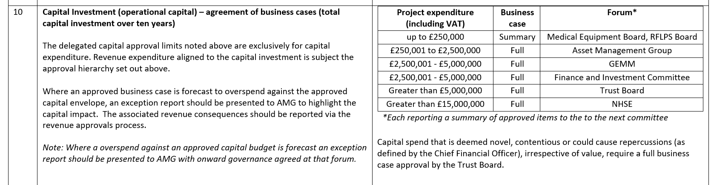

**Procurement thresholds**

To ensure all procurement decisions deliver value for money and comply with public sector procurement directives, competitive tenders or quotations are invited for the supply of goods and services. The following tables outline the correct procurement process to be followed relative to value and the type of product or service being purchased.

**Table five: Limits for quotations, tendering and contracting, including authority to approve and sign invoices, credit notes, leases and agreements per annum**

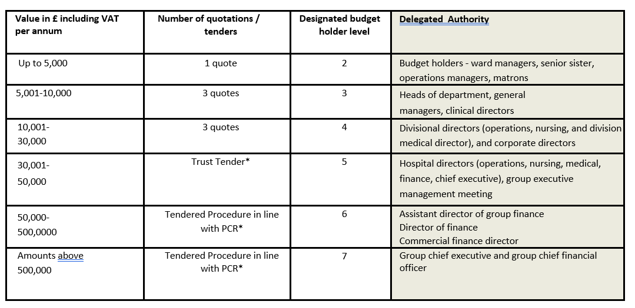

Where the opportunity has been advertised the Trust may shortlist suppliers, via a transparent supplier selection process, to take forward to the next stage of the procurement process.

Threshold limits represent the contract’s lifetime value (e.g. a 5 year contract of £25,000 per year requires £125,000 method, sign off and authorisation).

The cumulative amount spent with the supplier over a rolling 12-month period (e.g. 5 separate spends of £5k each will trigger the appropriate procurement process in line with the values above).

**Waiving of SFIs**

On occasion, the requirement to obtain quotations and tenders may be waived. This requires a separate approval process as detailed below. Where colleagues attempt to apply the waiver process retrospectively (i.e. goods/services have already been received but should have been subject to a waiver), this represents a breach of the SFIs and will be subject to a standalone approval process and separately reported as such to the Audit Committee.

**Table six: Waiver of Quotations and Tenders process (thresholds for approval)**

